Homework 2

**Pang-Yuxuan-1901110223**

****Question 1:****

**The spectra:**

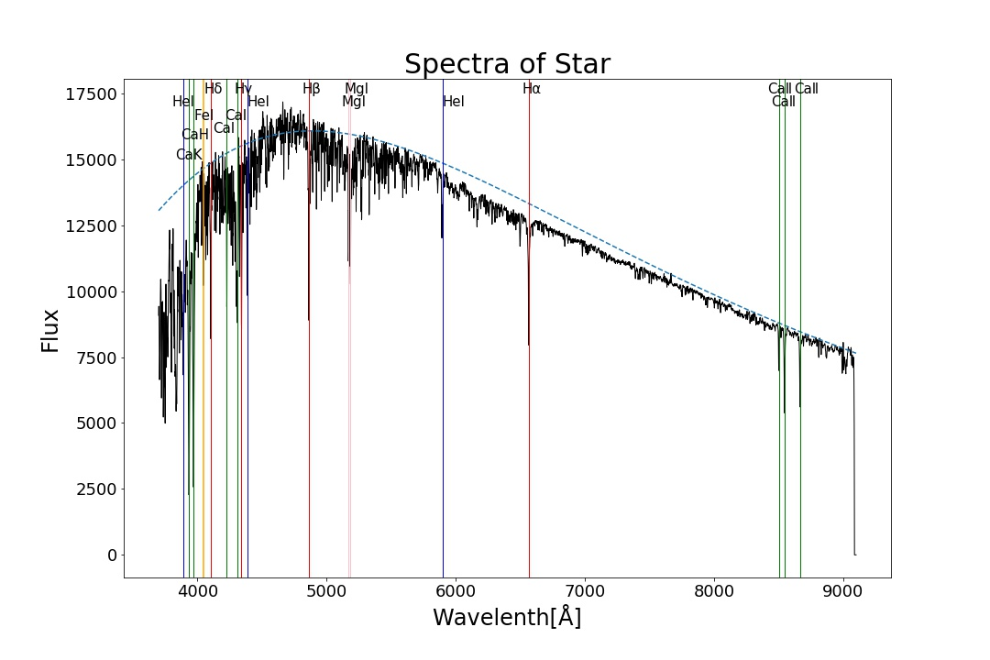

**PM2.5 analyze:**

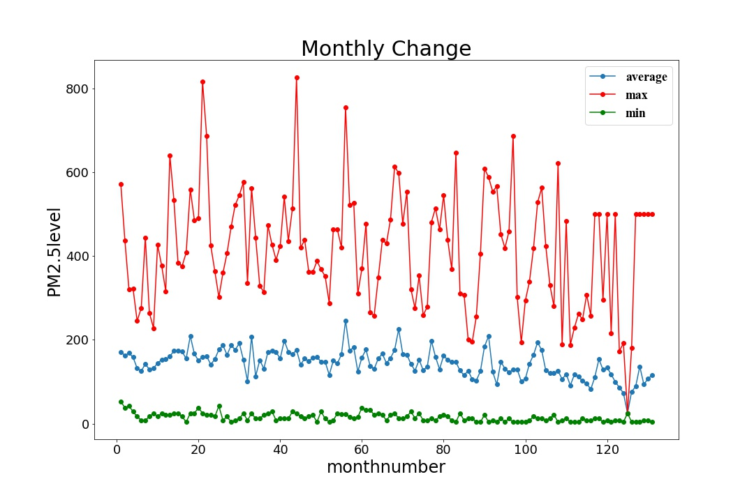

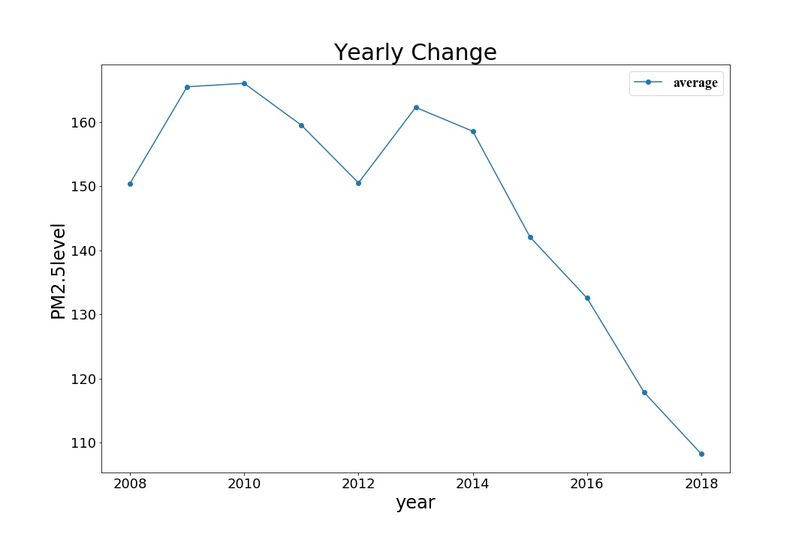

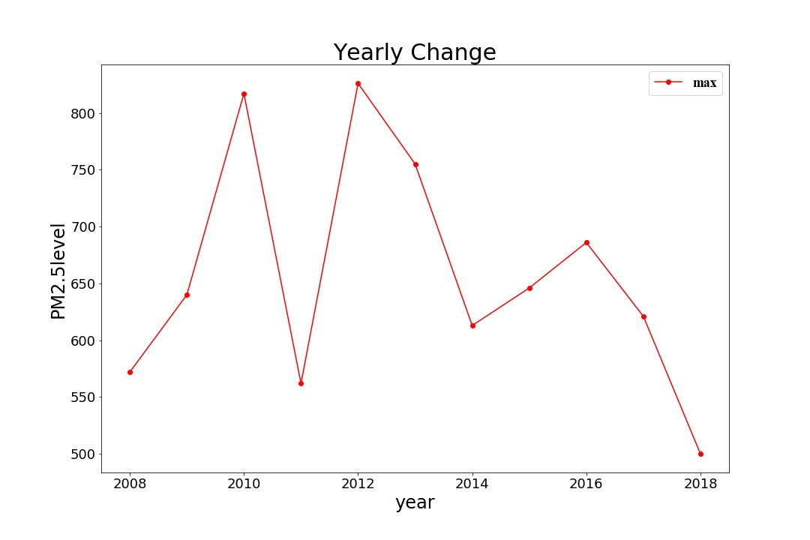

Question 2:

**First process the data in the following two steps:**

1. **Clean the data: kick of the data which have following character:**
   1. **Astrometric excess noise is larger than 1;**
   2. **The number of**is**;**
   3. **Error of****or****is too large:**



1. **Calculate the standard error for****and**:

From  we get:

;

From  we get:



**a)**

**Use the data of**and**to draw a heatmap (**in order to enhance the visual effect, the number in every grid has already been taken logarithm by)**, the result is shown in figure below:**

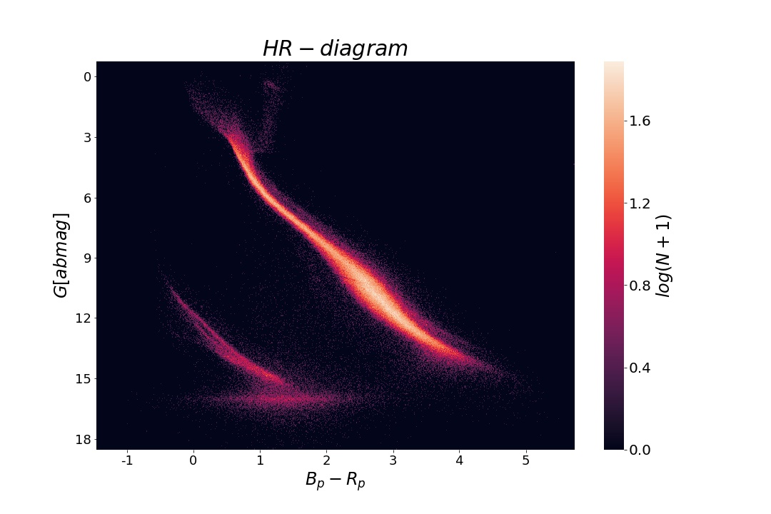

**b) Added the annotate of “main sequence” in the bright middle line and the annotate of “white dwarf” in the dim left-down corner line as well as the “Post Main Sequence”, shown in figure below:**

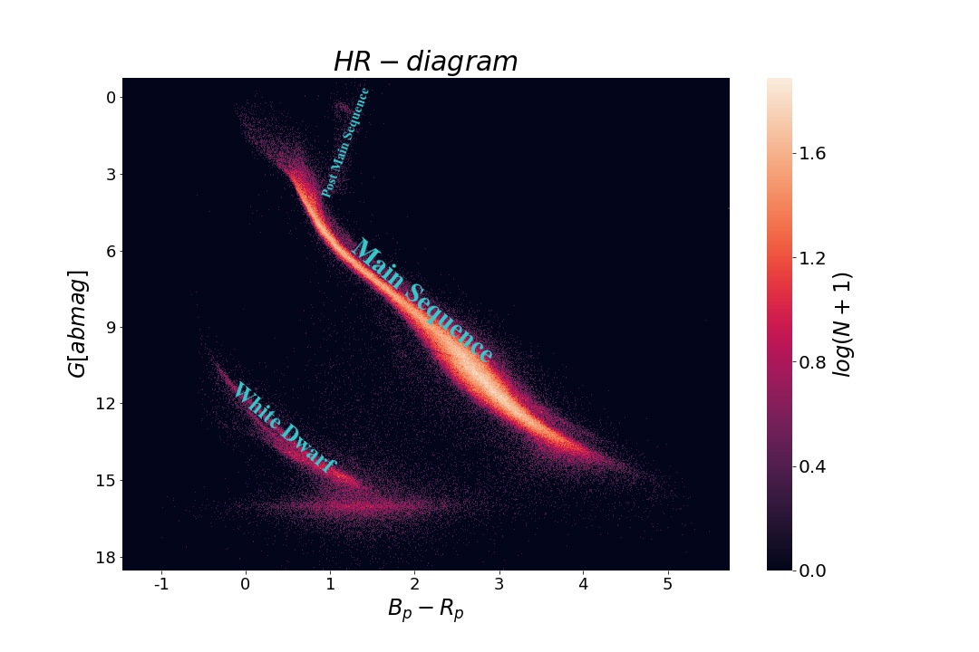

**c)**Both**and**have standard error we calculate before, so we add a Gaussian noise based onand in each star (see the heatmap below):

 and ,

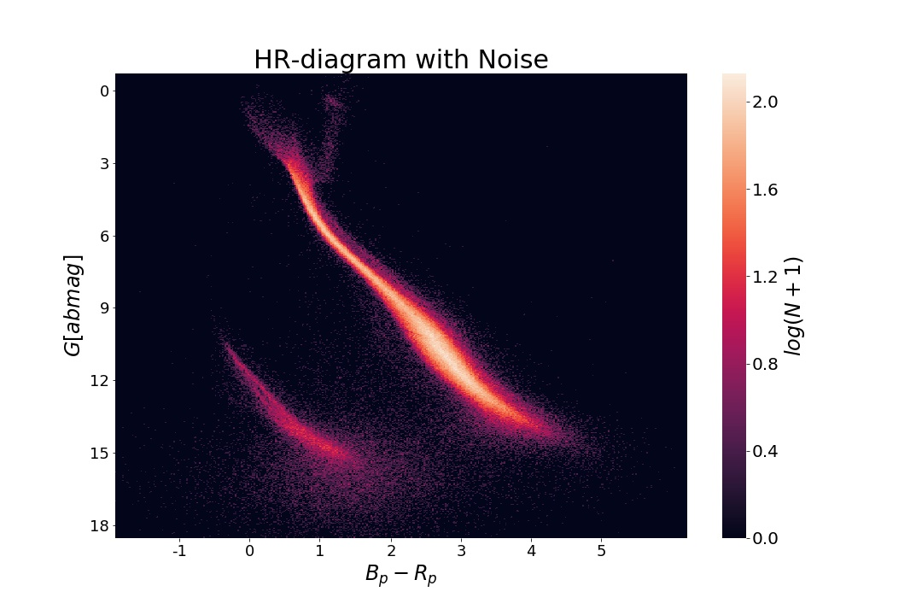

**Figure 2-c tells us that most of the stars don’t change the position in HR-diagram, except the stars around Gaia’s dark end limit, so the dim horizontal line of 2-a around magnitude 16 is not a staller type line but a diffuse distribution of brighter stars and darker stars.**

Question 3:

**a)**

**For Pleiades, I use the list “Pleiades member list (Belikov+ 1998)”;**

**For Hyades, I use the list “Hyades RASS observations (Stern+ 1995)”;**

**For NGC752, I use the list “Vilnius photometry”.**

**b)**

**I use the vizier to cross match the data between the lists of clusters and the Gaia** **DR2 data.**

**I will separate stars according to three parameters in order since the stars in the same cluster have similar parallax, ra speed and dec speed.**

**As for distance:**

**I assume the distribution of the distance obey Gaussian Distribution, and I am going to choose the stars in**because too narrow will lose some of the stars in clusters will too large will add the stars don’t belong to the clusters.

**As we know in Gaussian Distribution:** 

**So, I will choose the stars in distance where the number of stars in that band are more than 0.606 times the number of stars in maximum band.**

**As for moving speed: I will eliminate stars which are significantly different from the main peak.**

**For Pleiades:**

**The distance distribution of the cross-match result, as shown in figure below:**

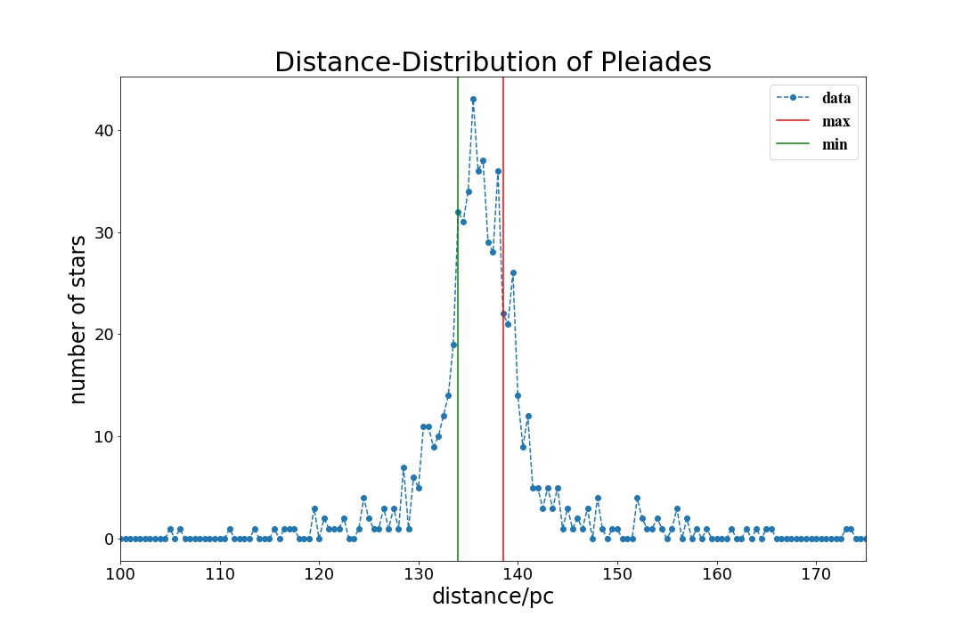

**After we choose the stars between the green line and the red line. The distributions of RA speed and DEC speed are shown in below:**

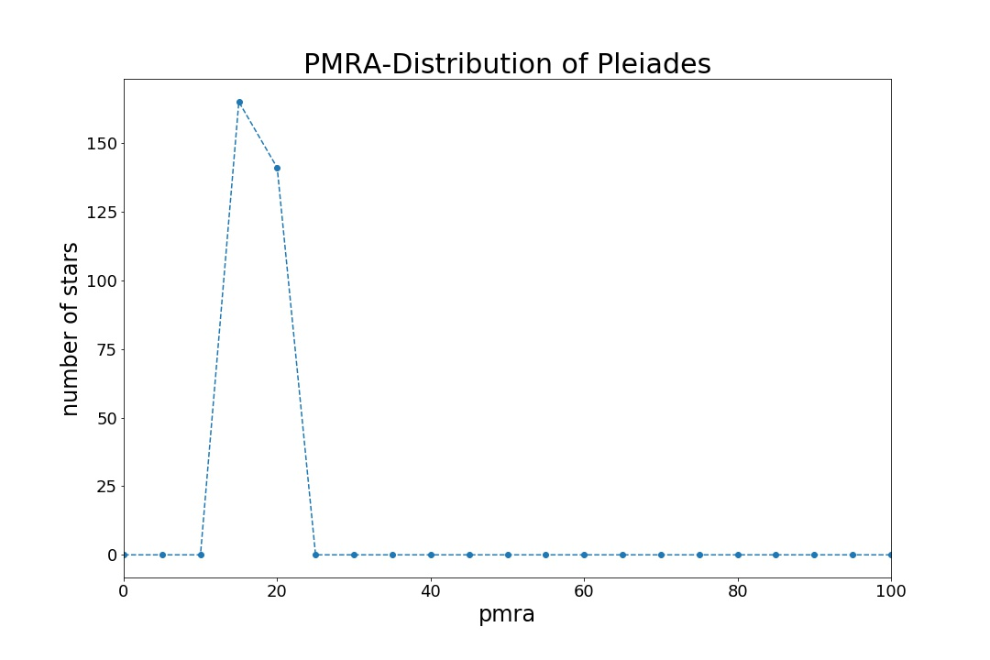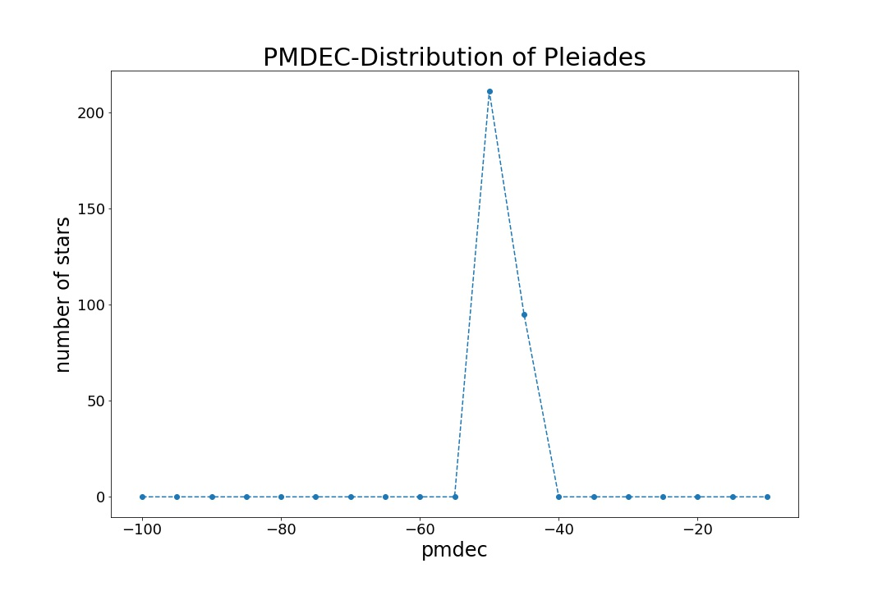

**As we can see, stars which are significantly different from the main peak. So I will accepted these stars as stars in Pleiades.**

**For Hyades:**

**The distance distribution of the cross-match result, as shown in figure below:**

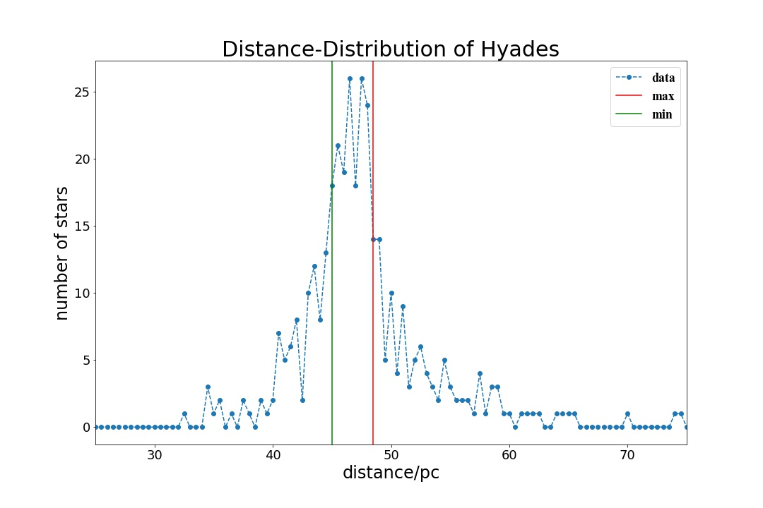

**After we choose the stars between the green line and the red line. The distribution of RA speed is shown in below:**

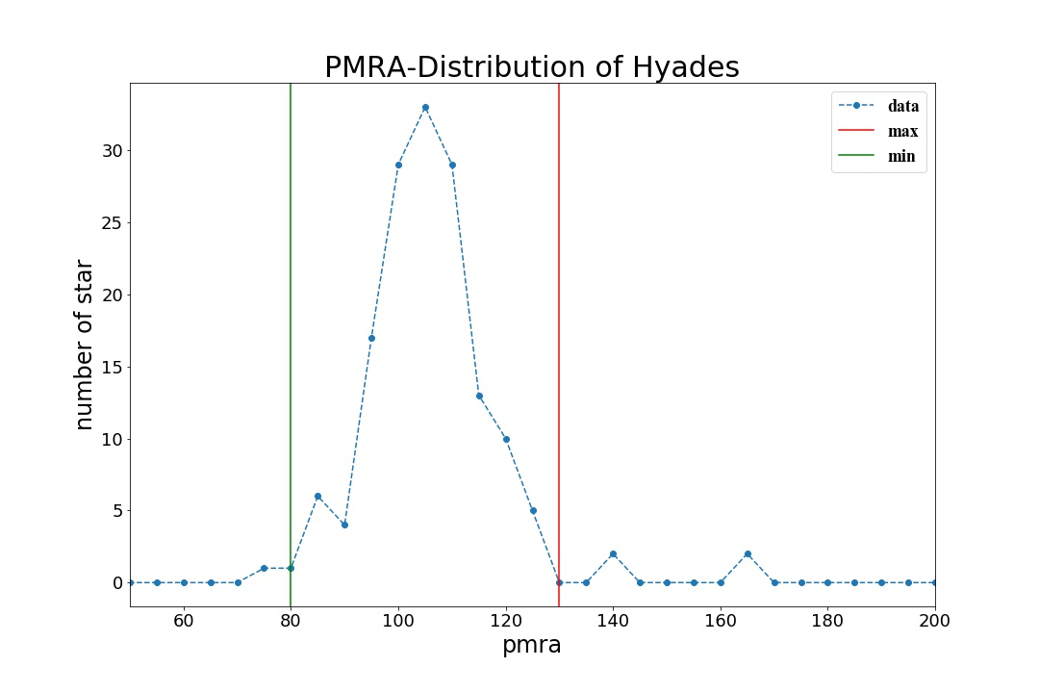

**There are some stars which have different RA speed, I choose the stars between the green and red line. Finally, we give the distribution of DEC speed after screen twice.**

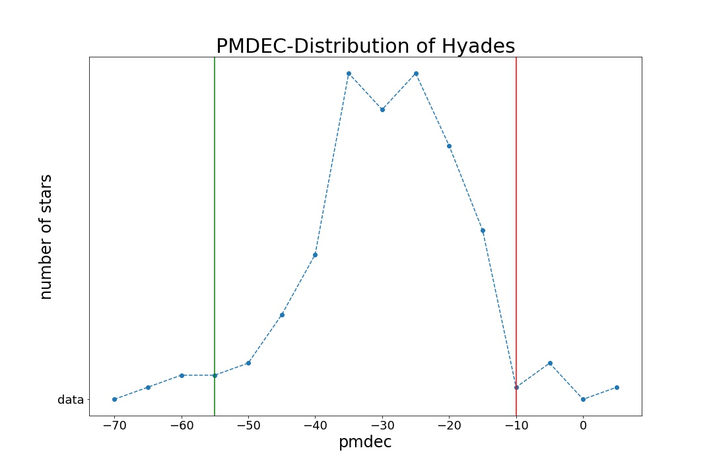

**Finally, we choose the stars between green and red lines.**

**For NGC752:**

**The distance distribution of the cross-match result, as shown in figure below:**

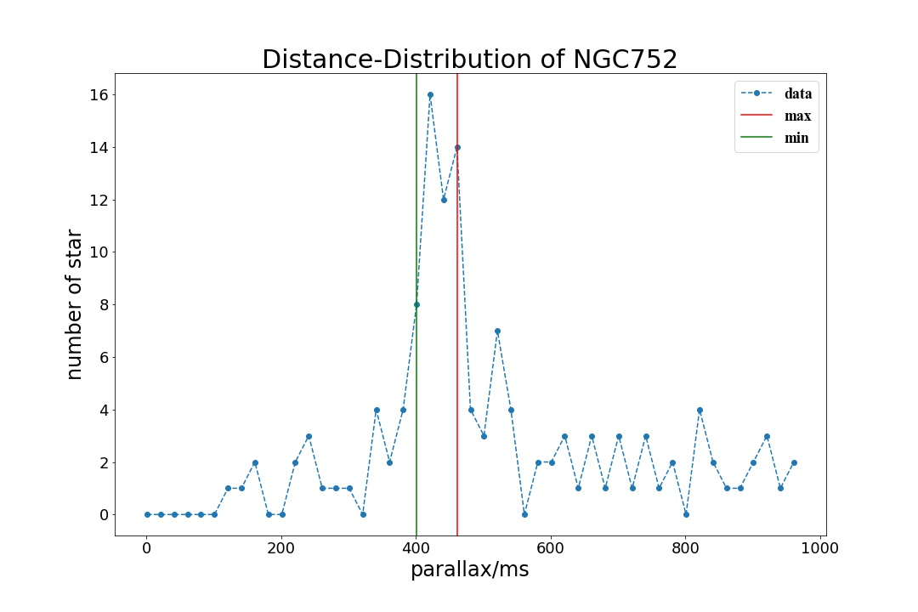

**After we choose the stars between the green line and the red line. The distributions of RA speed and DEC speed are shown in next page:**

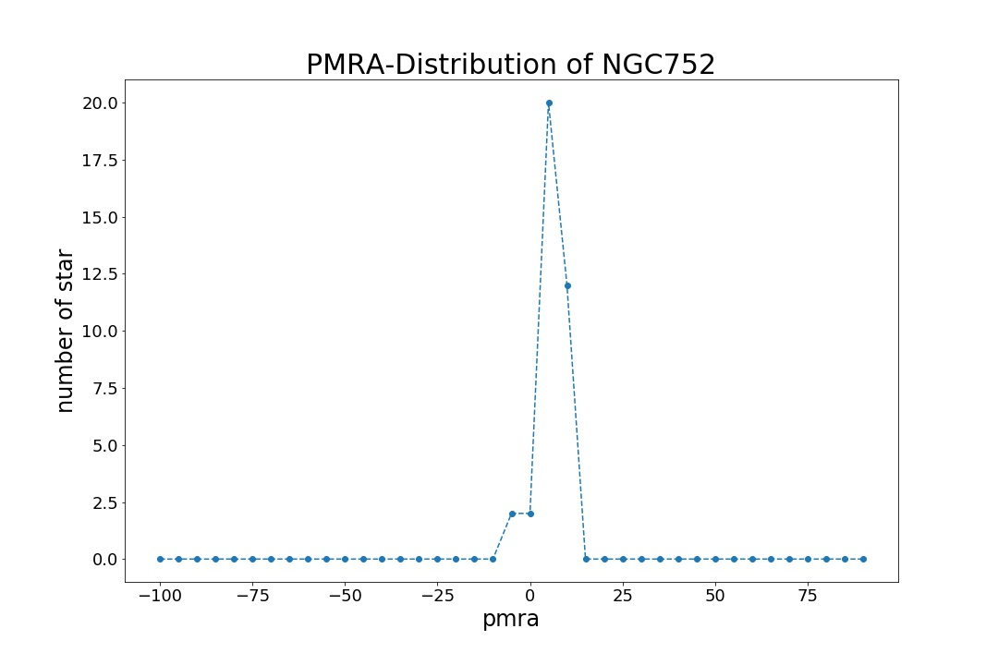

**As we can see, stars which are significantly different from the main peak. So I will accepted these stars as stars in NGC752.**

**For conclusion, the number of stars I choose are shown in table below:**

|  |  |  |  |  |
| --- | --- | --- | --- | --- |
| **Cluster** | **Number in list** | **Select by distance** | **Select by RA speed** | **Select by DEC speed** |
| **Pleiades** | **803** | **306** | **306** | **306** |
| **Hyades** | **400** | **152** | **147** | **137** |
| **NGC752** | **438** | **36** | **36** | **36** |

**c)**

**Using the data I get in (b), the HR diagrams of the open clusters are shown in figure below:**

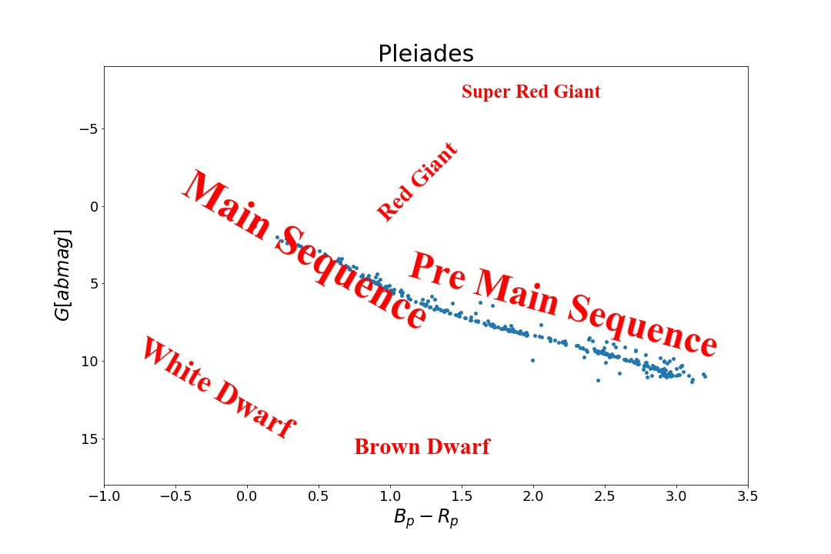

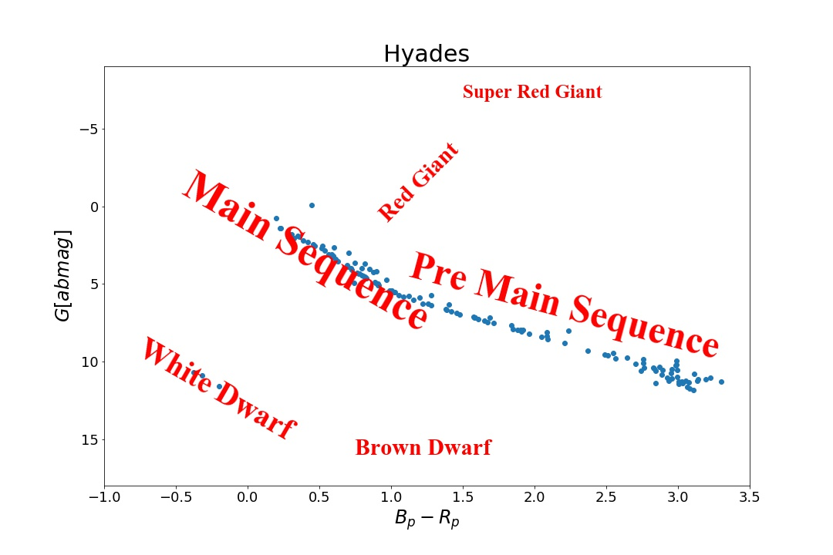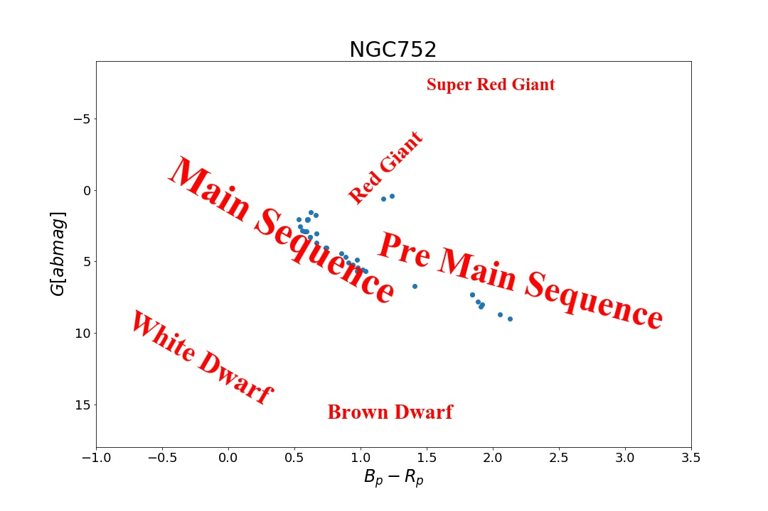

**There is different way for different kind of stars to generate energy:**

**1.In pre-main sequence, stars change their gravity energy into radiation and thermal energy.**

**2.If the mass of the star is too small to ignite the star, then the star will shrink slowly. They will become a brown dwarf by radiating their gravity energy**

**3.In main sequence stars generate energy by burning hydrogen to helium in their core, using pp chain for sun like stars or CNO cycle for massive stars.**

**4.Red giant generate energy by burning hydrogen to helium near their helium core.**

**5.Super Red Giant generate energy by burning elements heavy then carbon, finally change their core element to iron.**

**6.White Dwarf radiate their heat energy by their high surface temperature.**

**d)**

**Three clusters HR diagram is shown in below:**

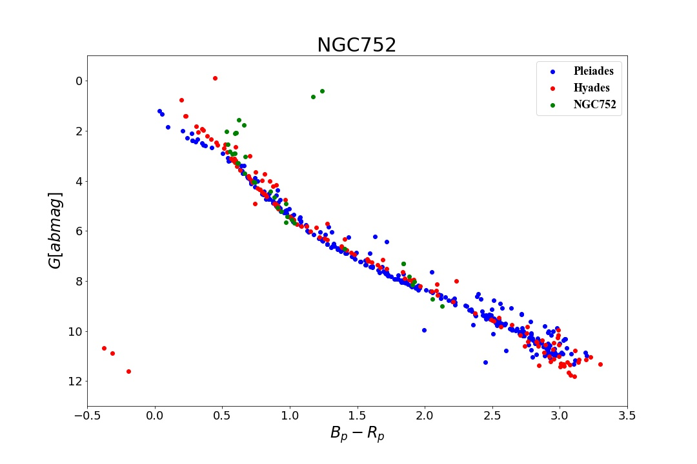

**1.There are different type of stars in different star clusters:**

**In Pleiades, nearly all of the stars are in main sequence as well as little low mass stars are in pre-main sequence.**

**In Hyades, most of the stars are in main sequence, but few stars are in white dwarf.**

**In NGC752, some of the stars are in main sequence, but other stars have left the main sequence into post-main sequence or Red Giant.**

**2.As the different we see in above, I can infer that Pleiades is the youngest one of the three because all the stars in Pleiades are in pre-main sequence or main sequence. While it is hard to compare with Hyades and NGC752 because the white dwarfs in Hyades may come from massive stars (less than 8 solar mass) while post-main sequence stars in NGC752 may come from low-mass stars (about the solar mass).**

**3. In the HR-diagram of Pleiades and Hyades, the higher the luminosity, the smaller the number of stars. This effect tells us that the mass-function in star clusters are decreasing as the mass going up. While there are more massive stars than less-mass stars maybe because of the long distance.**

**e)**

**I choose the direction:** , the distance distribution of this field star and the HR-diagram for field and cluster stars are shown in figure below:

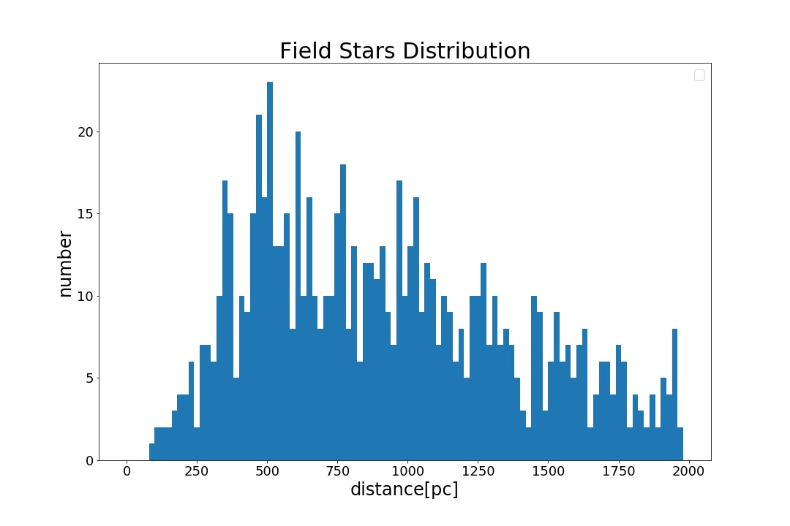

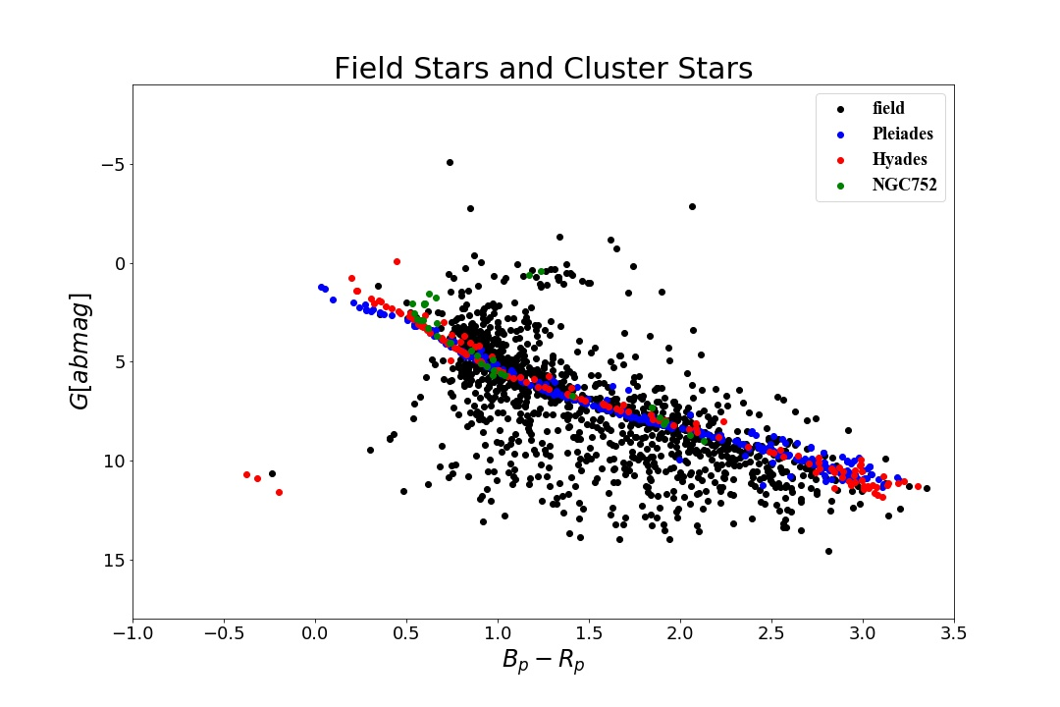

From the figure, the field stars must be born in different times because some of the middle mass stars have become red giant will some of more massive stars are still in the main sequence.

But from the clusters, in Pleiades, most of the stars are in main sequence while some low mass stars are in pre-main sequence; in Hyades, most of the stars are in main sequence, few massive stars are in post-main sequence and few stars become white dwarf; in NGC752, most of massive stars are in post-main sequence and some massive stars have become red giant while other low-mass stars stile in main sequence. All of the clusters conform to the SSP IMF model

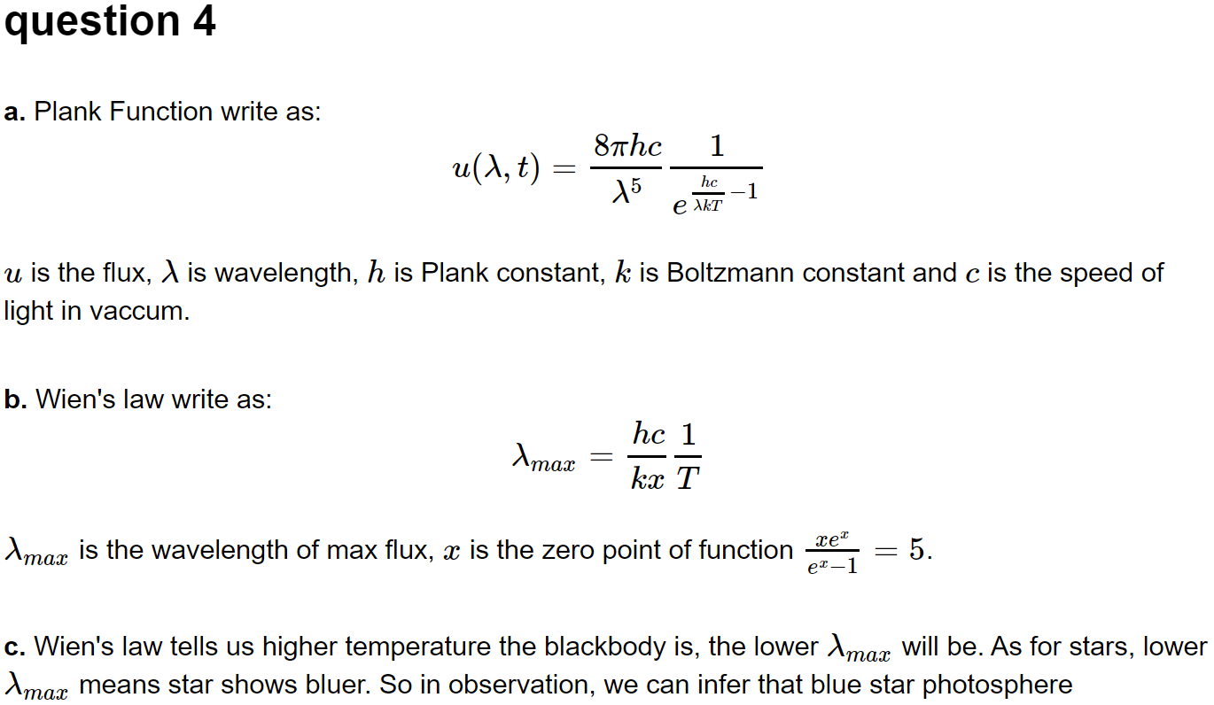

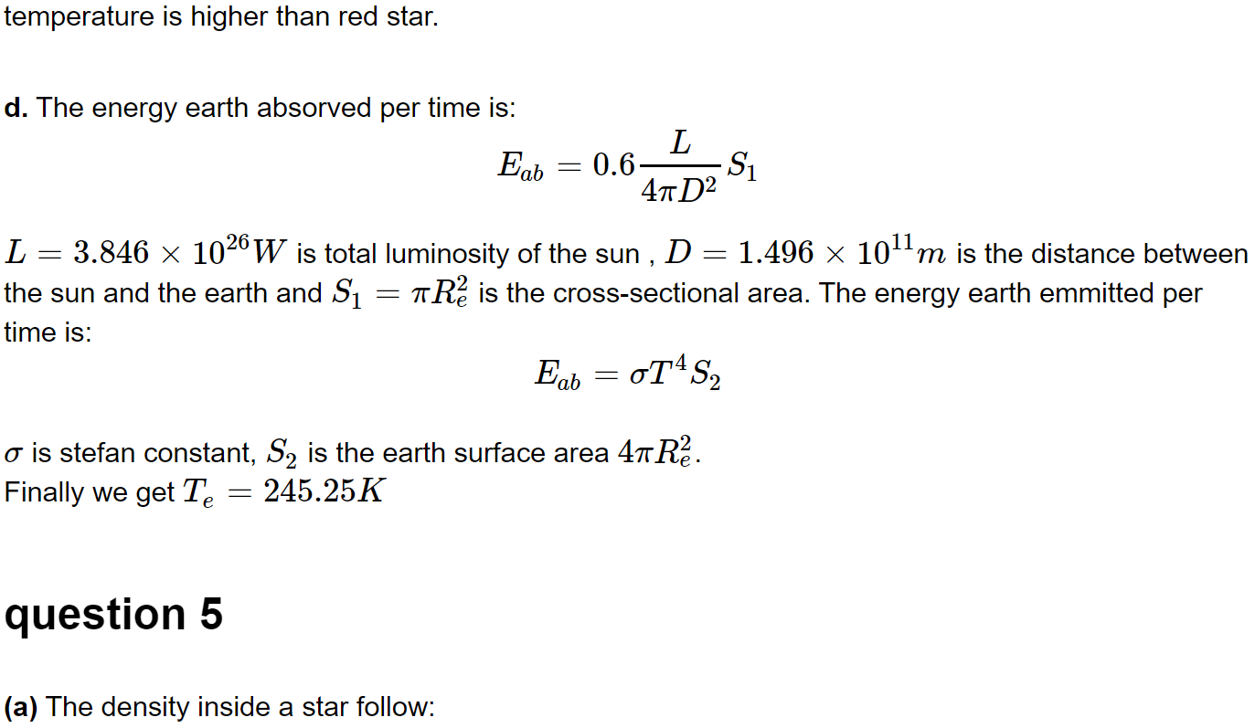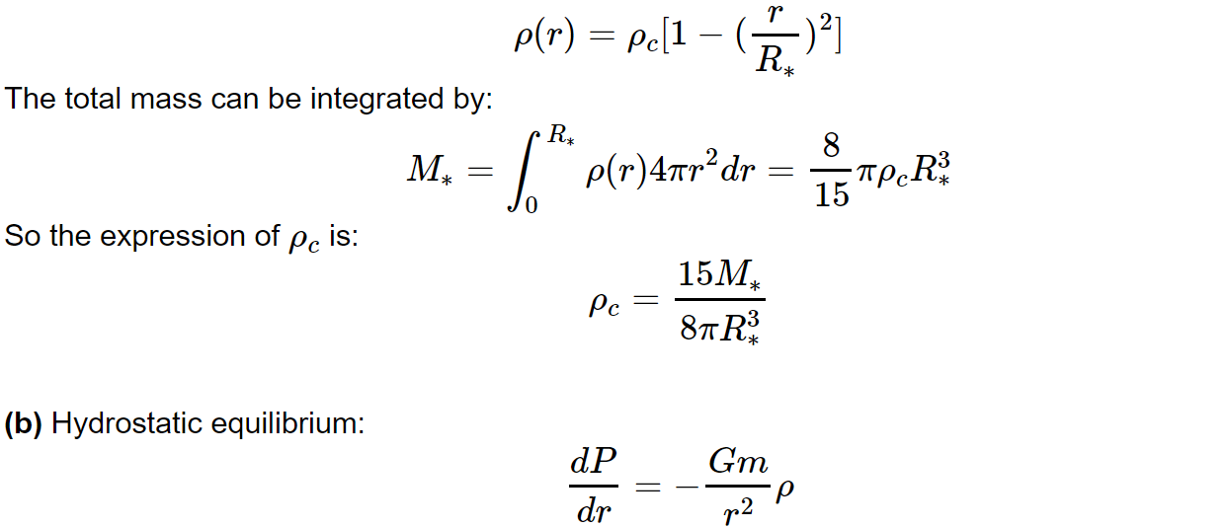

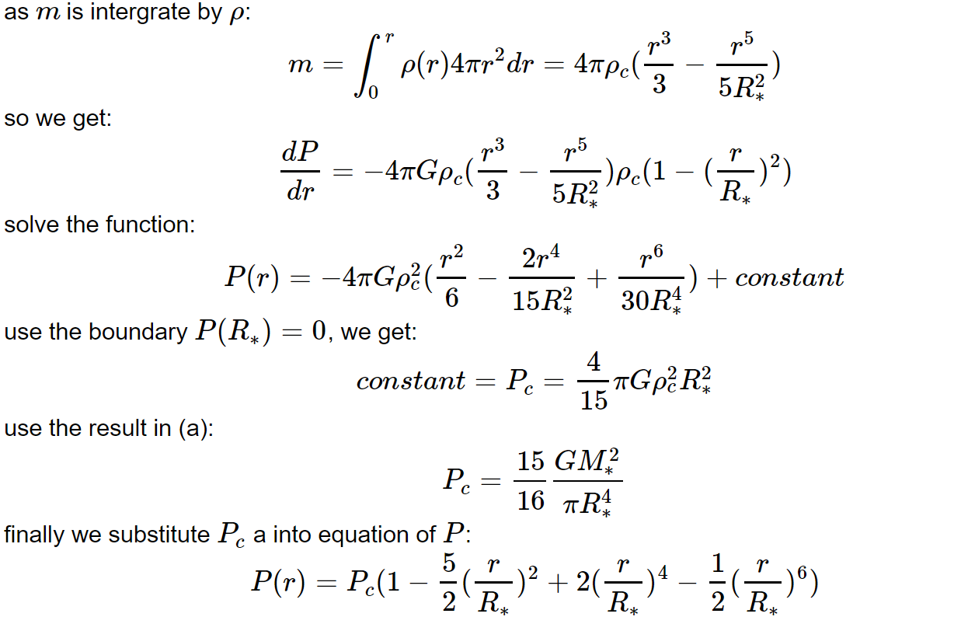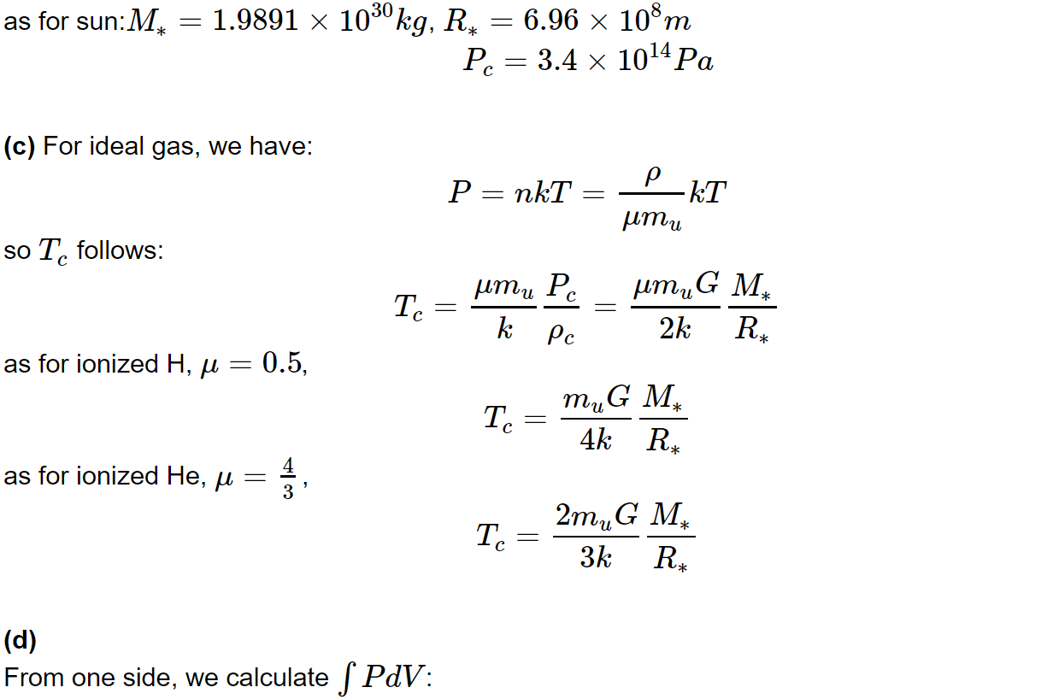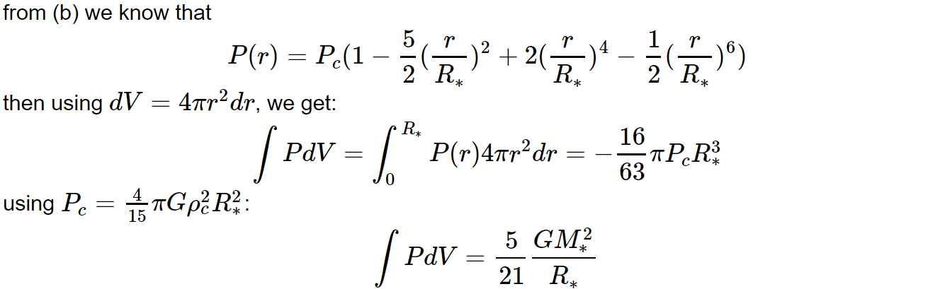

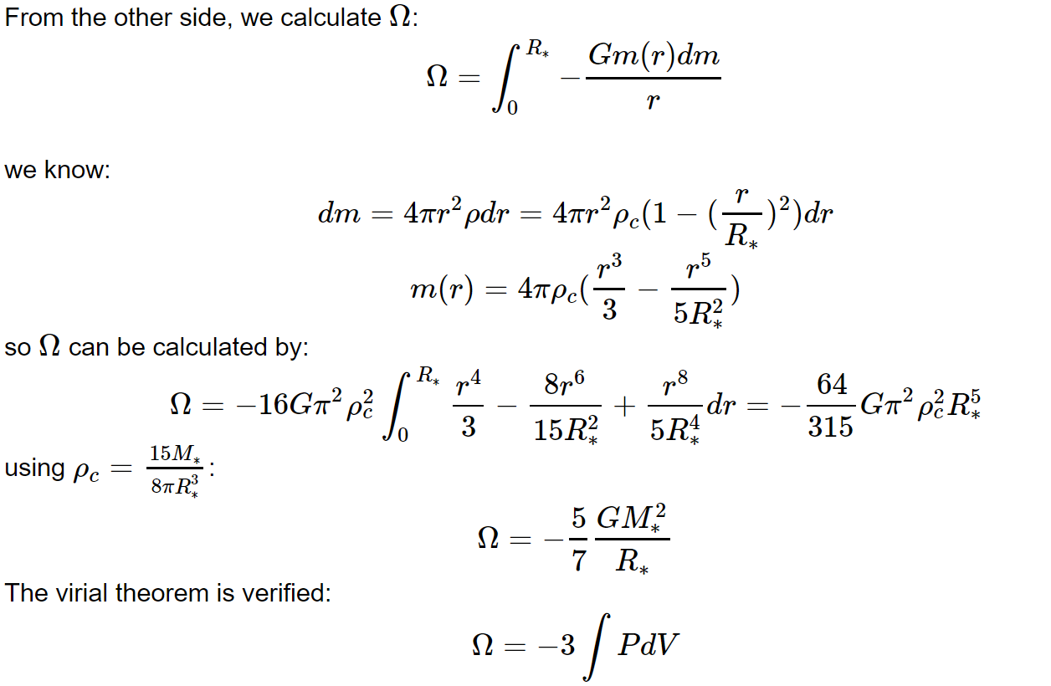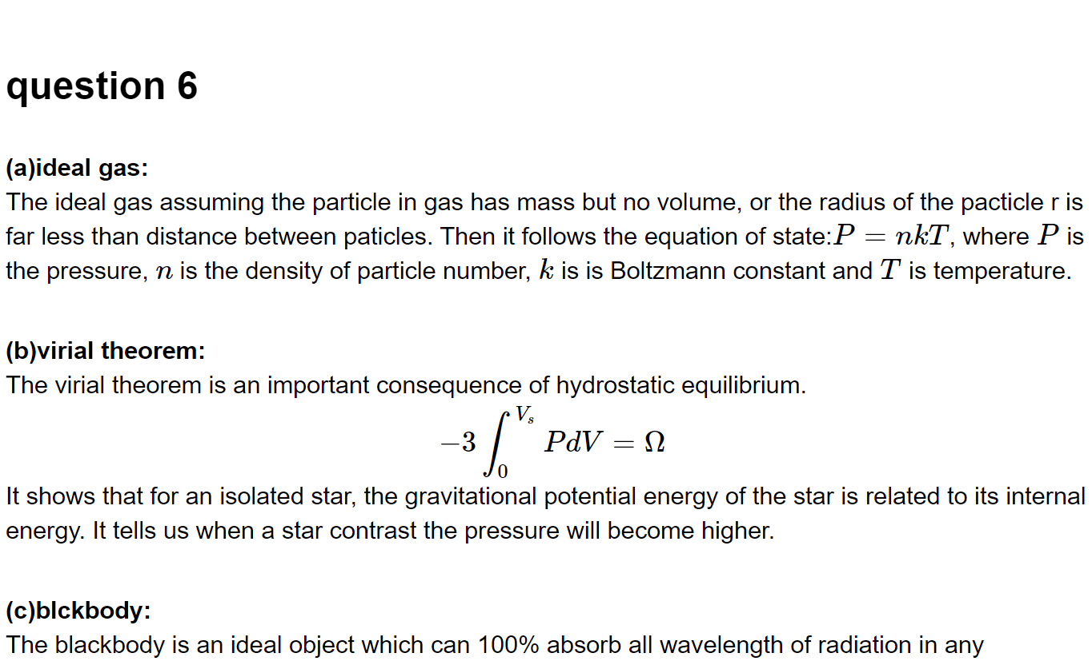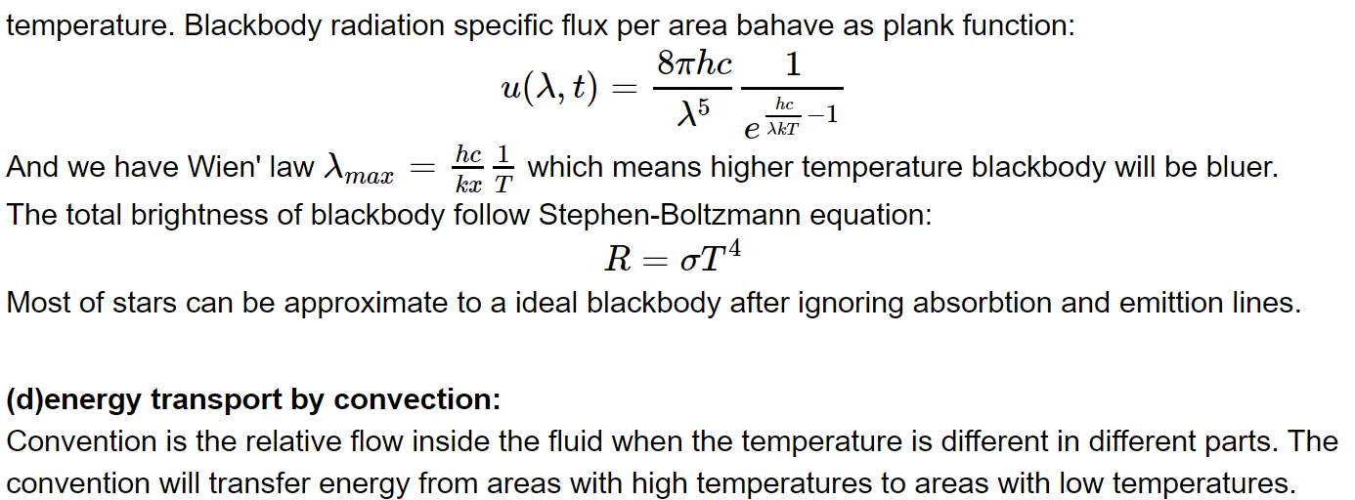

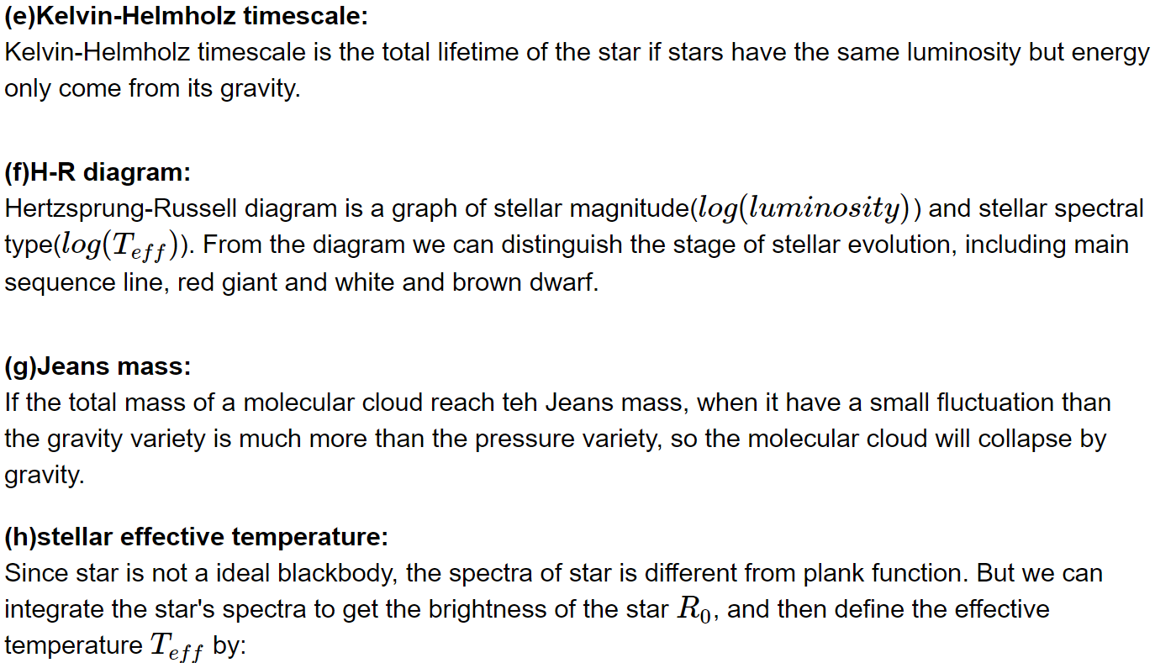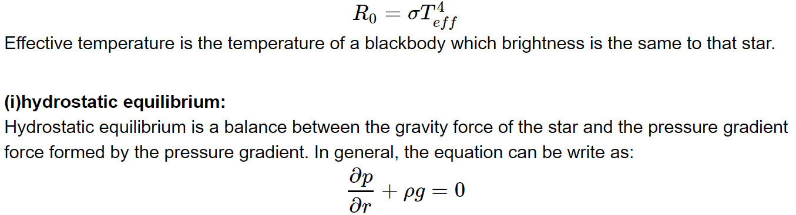

**Thanks to my roommate, Pan Zhiwei, who have a discussion with me in question 2 and 3.**

Appendix

The python code for question 3:

1.Total data analyse and distance selection:

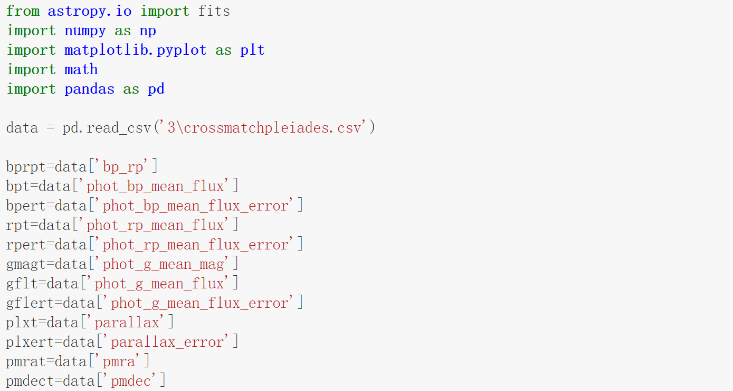

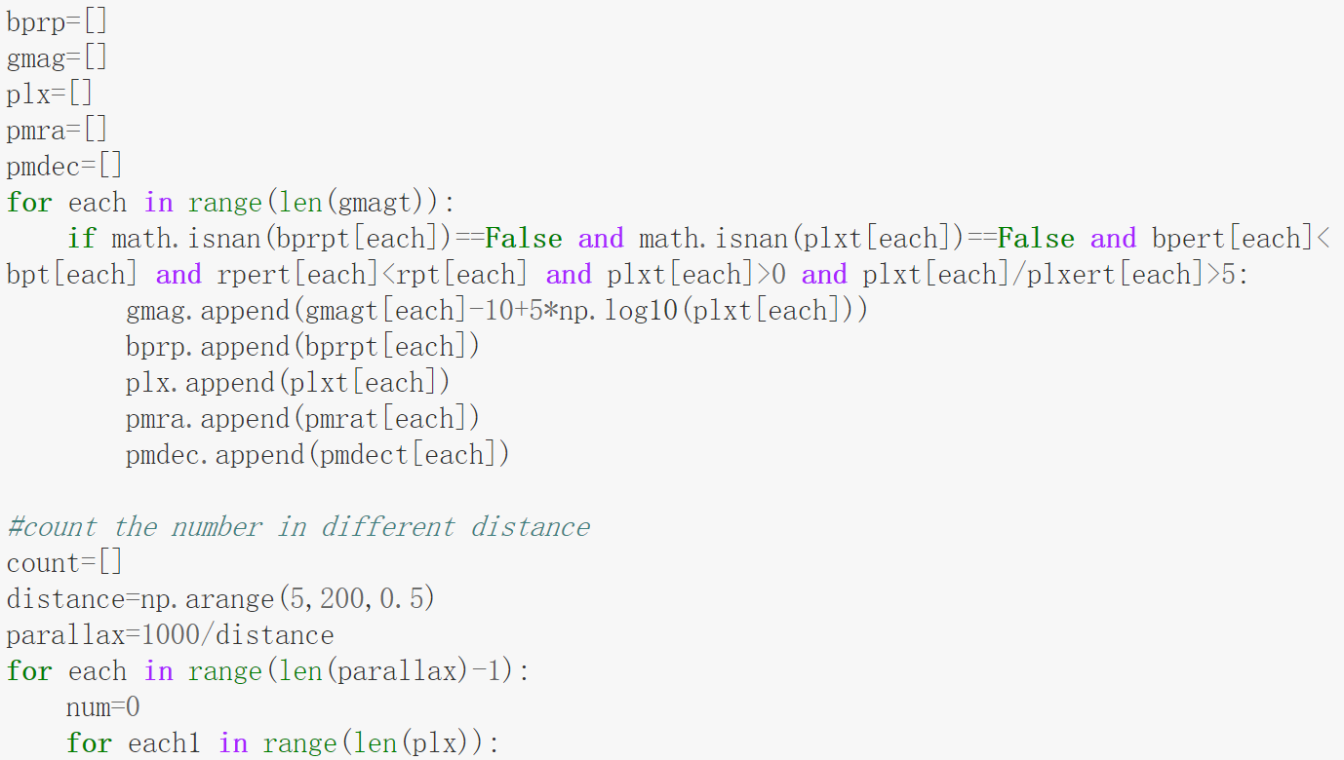 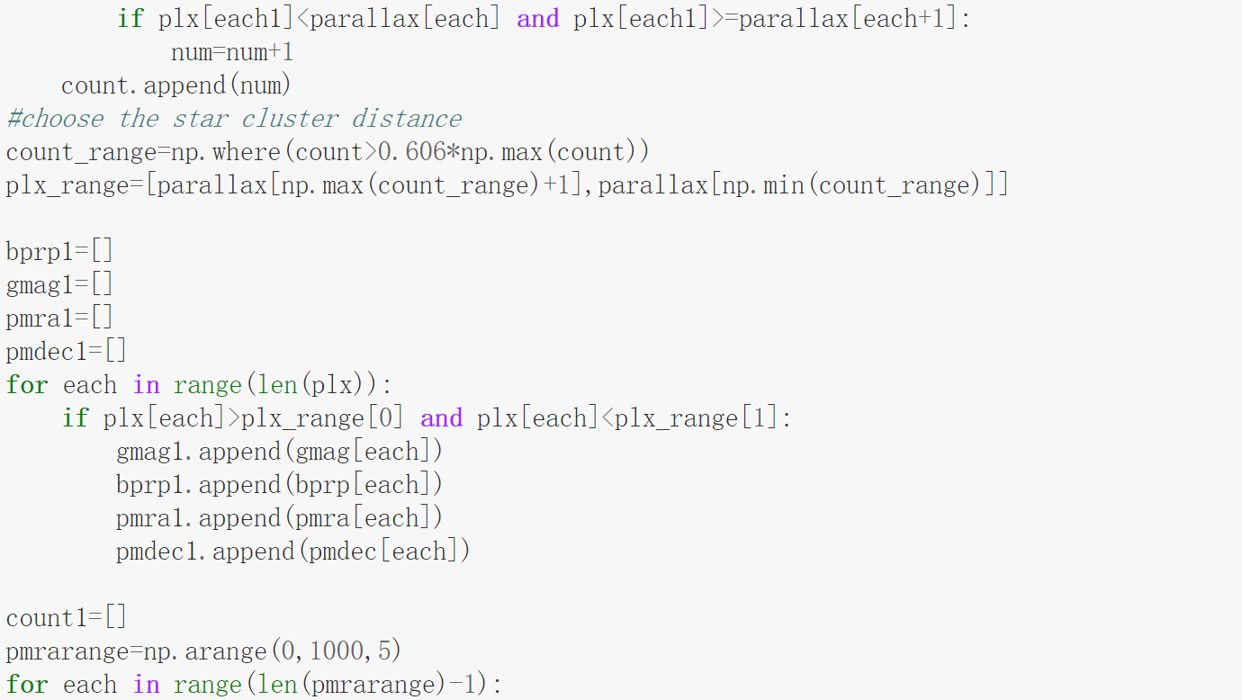 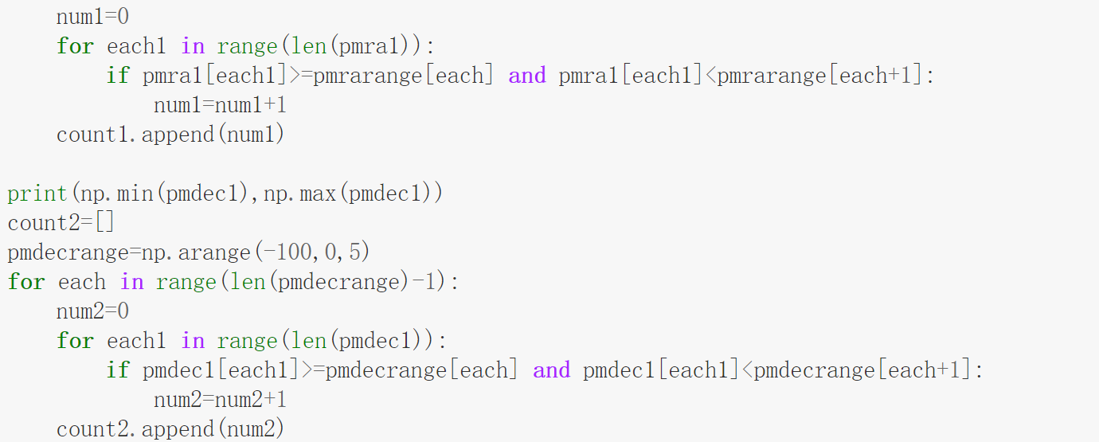

2.plot the distribution of distance, RA speed and DEC speed

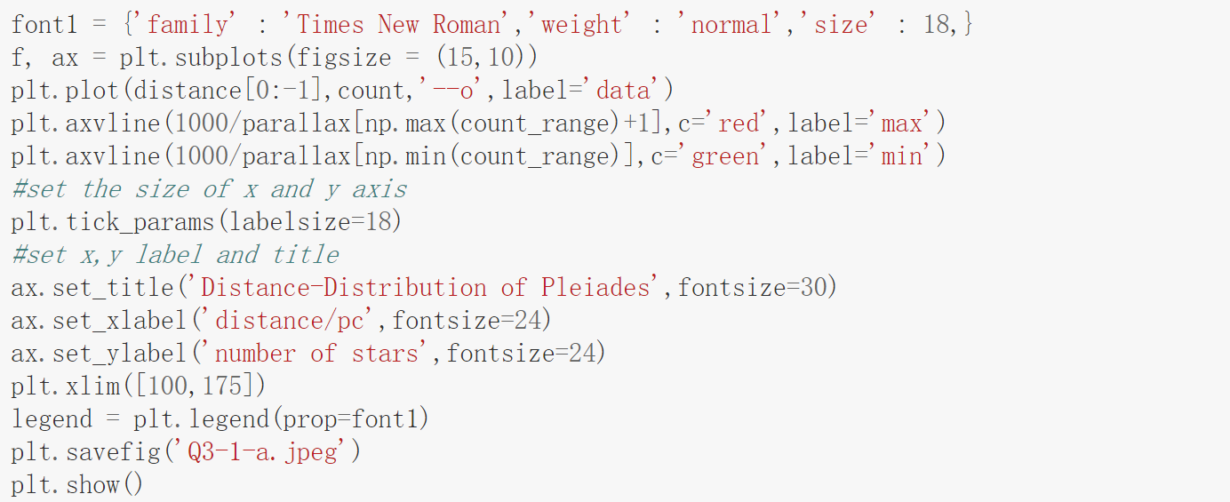 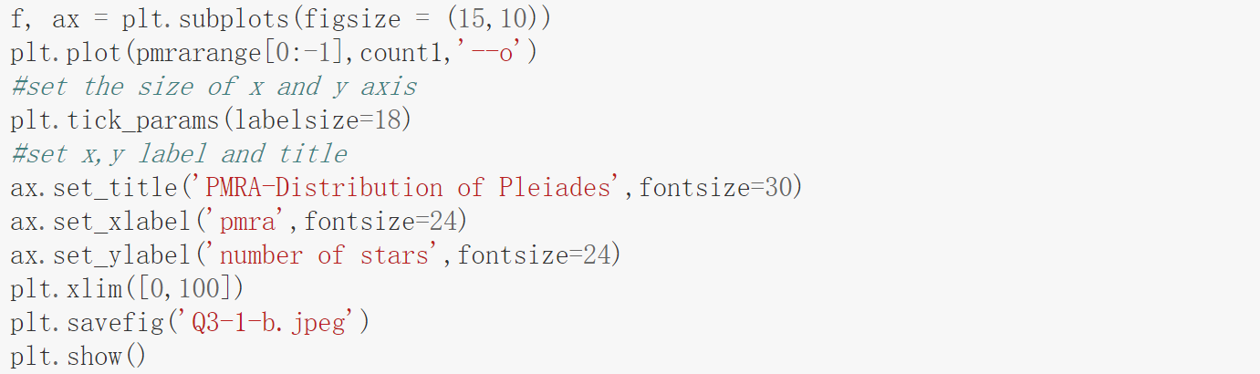 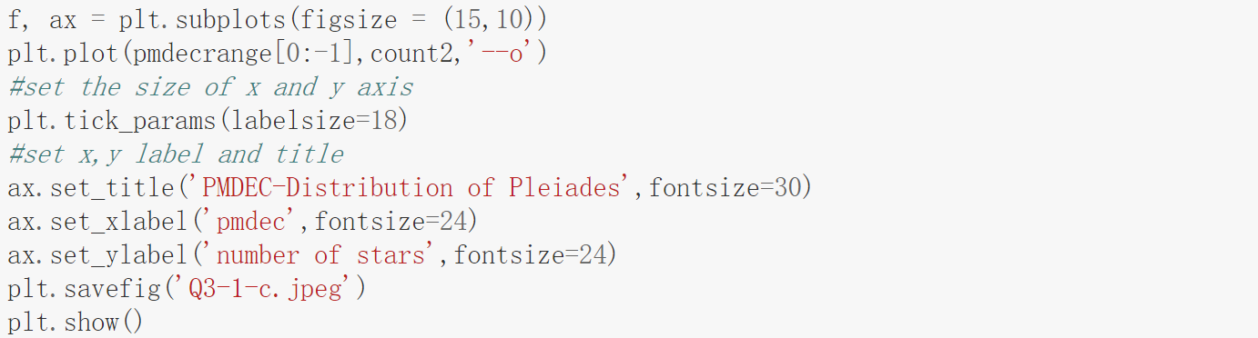

3.RA and DEC speed selection

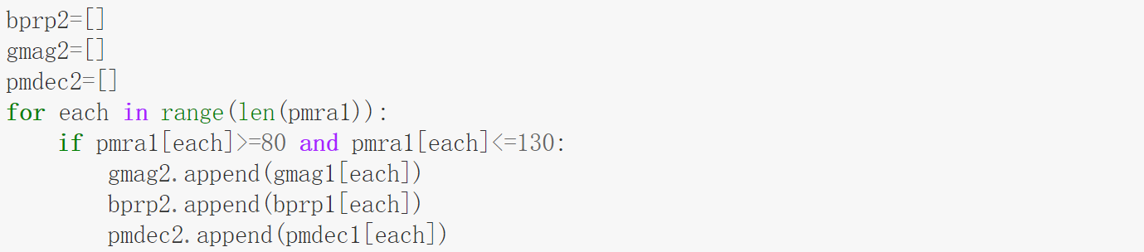

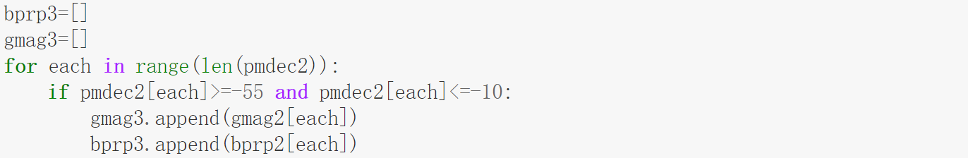

4.plot the H-R diagram for clusters:

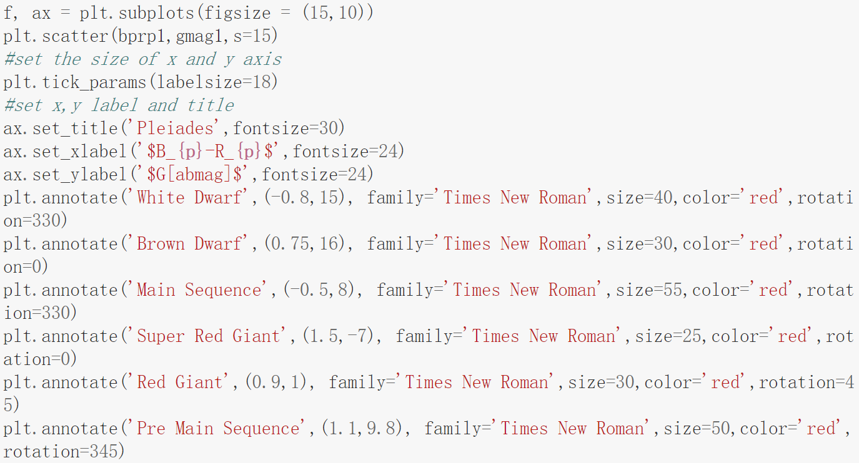 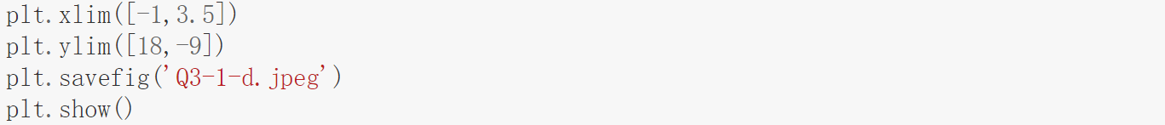

5.analyse the data in field stars

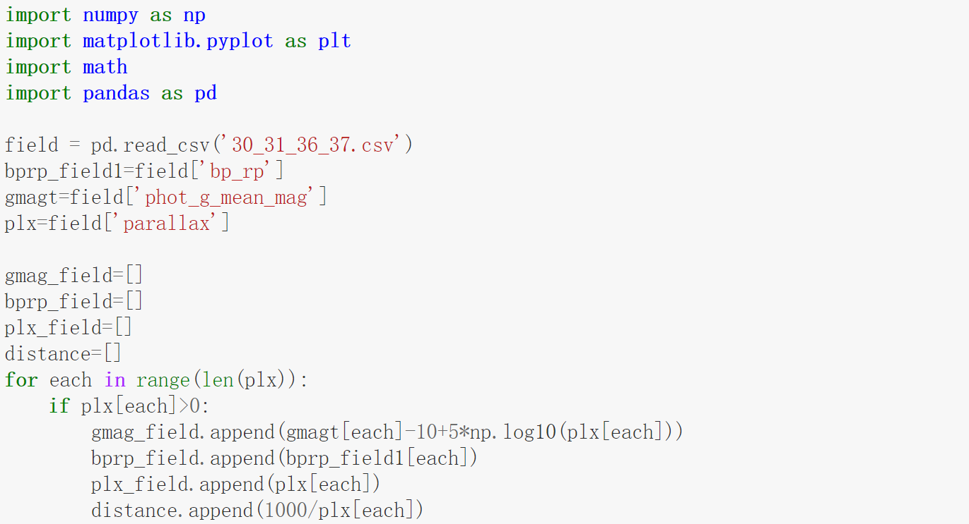 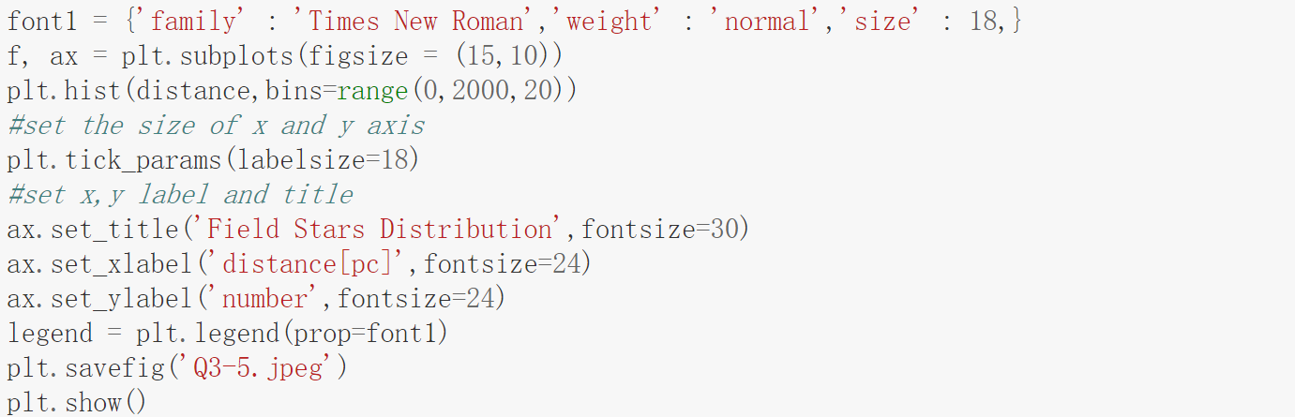

6.plot the data of clusters and field stars

